**Smart Home Automation using Bluetooth and wifi :**

**Team invincibles**

**By:**

**Sriharsha saluvaji**

**m.r. kiran kumar**

**gottipati vijaya kumar**

* **problem statement :**

**Controlling smart home automation using Wi-Fi and Bluetooth.**

* **Abstract:**

**Internet of Things (IoT) is nothing but connecting different real world objects to provide proper communication, synchronization, and inter-connecting between various devices or physical appliances is also known as "Things". The Home Automation System (HAS) is extension of current activities performed inside the home and this Home Automation System (HAS) can be developed easily now a day's, because of powerful computational devices and wireless sensor network(WSN), to provide user friendly and cost fairly home automation system. In home automation system (HAS), different technologies like Wi-Fi, Bluetooth and ZigBee are used for communication, and different devices like smart phone, tablet and laptop used for controlling various appliances. In this paper we detailed a survey on different home automation systems considering parameters like type of communication, cost, technology and efficiency of system. A comparative analysis of home automation systems is done. In future this system may have high demand and usage for automation of the "Things". Using Home Automation System (HAS) our home will be smart home that can operate without any physical interference of human being.**

* **Introduction :**

**Mobile We are living in the world of automation where most of the systems are getting automated, such as industrial automation, homes and other business sectors. Home automation systems are advancement to the mechanization processes wherein human efforts are needed with the machinery equipment to operate various loads in homes. It involves automatic controlling of home appliances using different technologies and controllers over desktops, laptops smart phones or tablets .Home automation system makes the operations of various home appliances more convenient and saves energy. With the energy saving concept, home automation or building automation makes life very simple nowadays. It involves automatic controlling of all electrical or electronic devices in homes or even remotely through wireless communication. Internet of Things (IoT) is an ecosystem of connected physical objects that are accessible through the internet. The ‘thing’ in IoT could be a person with a heart monitor or an automobile with built-in-sensors, i.e. objects that have been assigned an IP address and have the ability to collect and transfer data over a network without manual assistance or intervention. The embedded technology in the objects helps them to interact with internal states or the external environment, which in turn affects the decisions taken. The IoT based home automation system will allow the user to control their home appliances over the Internet. The advanced homes are automated through the web and the home machines are controlled. The user commands over the internet will be received by the Wi-Fi modem. Arduino microcontroller has an interface with this modem. Microcontroller processes user’s commands and controls home appliances**

* **HARDWARE USED:**

**1. Esp8266**

**2. Bluetooth module**

**3. basic shield**

* **Software used :**

**1. arduino ide**

**2. node red**

**3. Mit app developer**

* **PROPOSED SYSTEM :**

**The purpose of this project is to develop a simple Home Automation system prototype for controlling various household devices using your Android Smartphone. There are two ways through which a user can control this system –using Bluetooth or through WIFI.**

**User will control this system using an Android App. When user opens the App, he/she will be presented with two options –Bluetooth or WIFI. If the user is within short range of the system, he/she can select the Bluetooth option. In Bluetooth mode, the app will communicate with Arduino using Bluetooth. If the user is far away from the system or outside the home, he/she can select the Wi-Fi option. In Online mode, the user commands will be transferred over the WIFI and Arduino will use ESP8266 Wi-Fi module to receive those commands.**

* **Block diagram :**

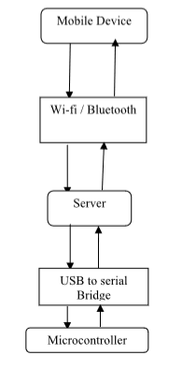

* **Description of components :**
* **ESP 8266(NODE MCU):**

**The esp 8266 is a low cost Wi-Fi micro chip with full tcp/ip stack and microcontroller capability produced by manufacturer espressif systems .the chip first came to the attention of western makers in aug 2014 with the esp 01 module made by third party manufacturer made by AI thinker .This small module allows microcontroller to connect to a wifi network and make simple TCP/IP connections using hayes style commands .However first there was almost no English language documentation in the chip and command it accepted . The very low price and the fact that there were very few external components on the module, which suggested that it could eventually be very inexpensive and attracted many hackers to explore the module, chip and the software on it as well as to translate the Chinese documentation.**

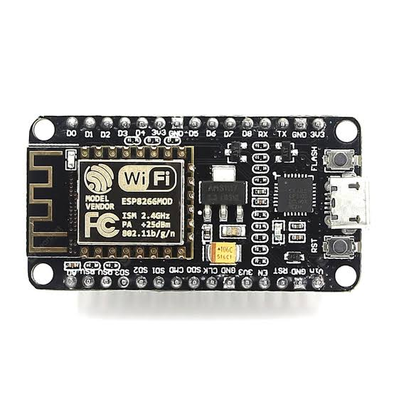

* **BLUETOOTH MODULE :**

**Bluetooth Module: Bluetooth module is an easy to use Bluetooth SPP (Serial Port Protocol) module, designed for transparent wireless serial connection setup. The Bluetooth Module can be used in a Master or Slave configuration, making it a great solution for wireless communication. This serial port Bluetooth module is fully qualified BluetoothV2.0+EDR (Enhanced Data Rate) 3Mbps Modulation with complete 2.4GHz radio transceiver and baseband.**

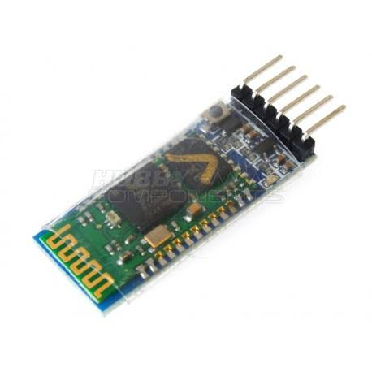

* **PSEUDO CODE :**

**Step 1: The user selects either Bluetooth or wifi option from the android app.**

**Step 2: If user selects Bluetooth option, the app establishes connection with the Bluetooth module.**

**Step 3: Else if wifi option is selected, the app establishes connection with ESP8266 Wi-Fi module.**

**Step 4: Arduino reads the status of various home appliances, either they are off or on and sends the status back to the android app.**

**Step 5: Android app processes the received data from Arduino and displays it on the screen.**

**Step 6: User clicks the appliance button that he/she wants to turn on or off and the android app sends command along with that appliance number to the Arduino.**

**Step 7: Arduino processes the received command and retrieves appliance number along with ON or OFF instruction.**

**Step 8: Based on the received appliance number, Arduino sends HIGH or LOW signal to the relay module to switch on or off that appliance.**

**Step 9: Arduino sends the result back to the android app.**

**Step 10: End.**

* **Stimulation results :**

**We developed an android application which can be used to ON or OFF the home appliances. The following screenshots and images shows the status of various appliances connected to the system along with the switches to switch them ON/OFF.**

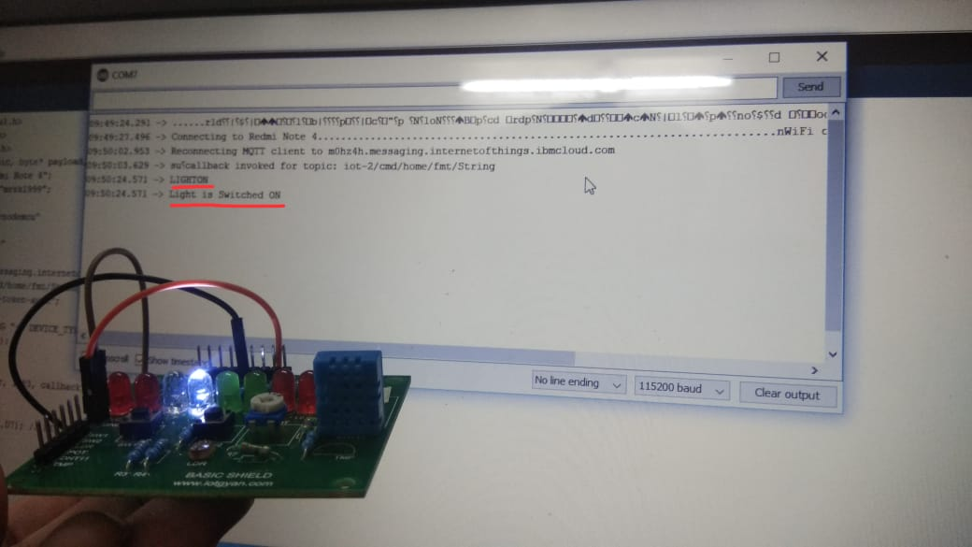 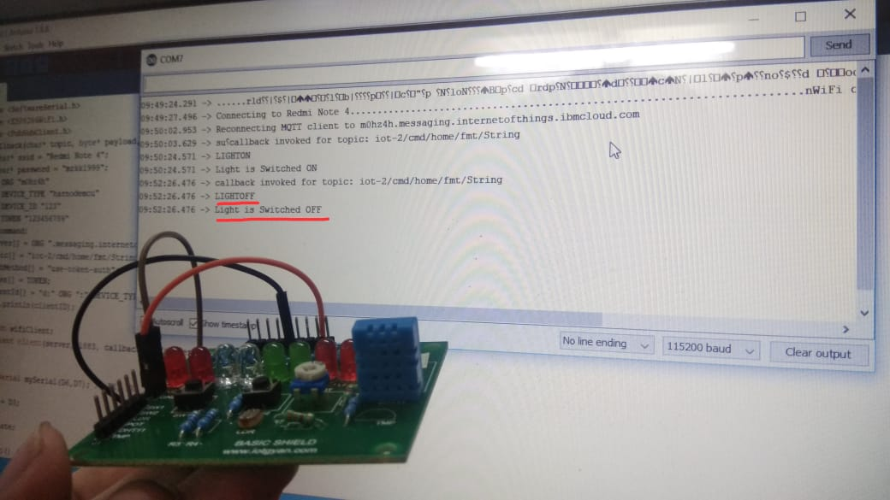

 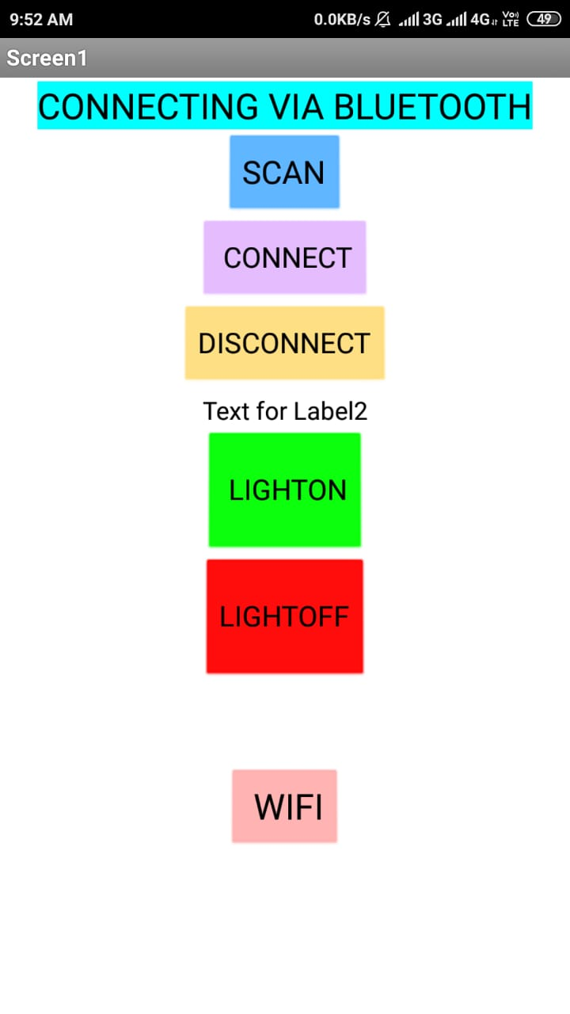

* **Conclusion and future work :**

This paper gives a basic idea on how to develop a simple home automation system to control various home appliances using wireless technology such as Bluetooth and Wi-Fi. The main objective of this project is to give handicap people an easy access to various home appliances.